Creating Key Requests

- Log onto https://isweb.viu.ca/VIUWEB/main.asp
- Under My Apps, choose Facilities Key Request. This is a drop down menu and you may have more than one option to choose from.

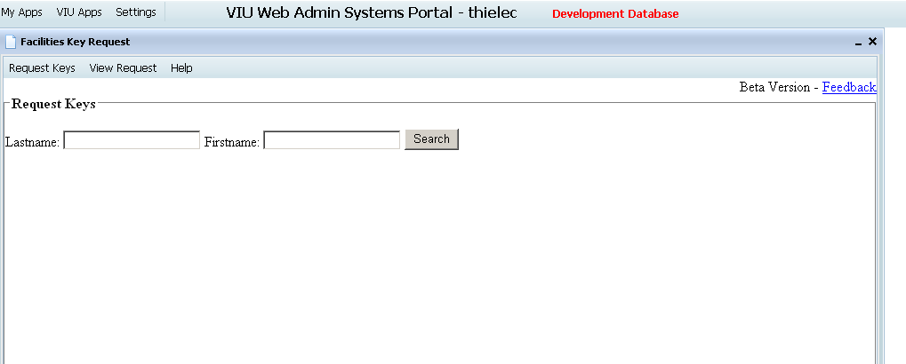

- Enter the last name, first name, or one or the other, and hit the search button.
- A list with all the similar entries will populate, choose the correct match by double-clicking on the name.
- The current keys of the employee chosen will show as per below. You will see the Room Request Details below the current access, choose the campus, building, room, number of keys and choose the Add Key button. Card access can also be requested in this application; the system will know if the room is a key or a card. If the employee already has the key that is being requested you will see a prompt stating this. If a duplicate key is required, please choose a reason from the Reason tab and use the notes section if more details are required. This is where you should state if a key has been lost. In the notes tab, you should list an appointment end date for an employee if applicable.
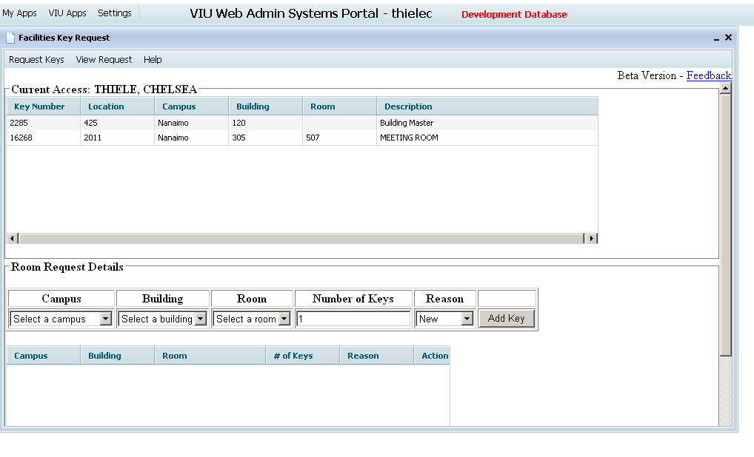
- Once you have added a key, you will see your request populate below the room request details. Scroll to the bottom of the screen and hit submit once complete. You will see a prompt stating ‘Request Submitted’.
- To view requests that you have submitted hit the View Request tab at the top of the form.
- The status tab will be updated as Facilities completes your request. The following actions will be noted:
  - Requested – in the queue.
  - Cancelled – request has been cancelled. Contact Facilities if unsure of reason.
  - Waiting for pick-up – request is complete and will need to be picked up from the Facilities Office (Building 120/Room 200) by the employee. Picture ID will be required when picking up.
  - Completed – employee has picked up key and the request is complete.
  - Rejected – the request is not approved, contact Facilities if unsure of reason.
- Building Master, Grand Masters and certain secure rooms will require authorization. If you select one of these rooms, an email will be sent to the appropriate Dean or Director requesting approval. The Dean/Director will receive an email with a link requesting him/her to approve a request. Once they click the link they will be brought to the website and are able to approve/deny request.
- Facilities will hold keys for three months, they will be de-assigned if not picked up within that time frame and a new request will need to be submitted.
- Employees can pick up keys between 730am – 4pm Monday to Friday from Building 120/Room 200. Picture ID needs to be shown to pick up keys. An email will be sent to the employee when keys are ready outlining this.
- No paper work will be given when keys are picked up. Employees can also view which keys they have in their possession on Star Garden.
- All keys should be delivered back directly to the Facilities office when no longer required.
- Direct any questions to facility@viu.ca or call Local 6500.

Thank you,
Facilities Services and Campus Development

